SUMMER INSTITUTE 2019
Final Report
For the third summer, undergraduate and graduate students participated in the annual Summer Institute program over two weekends: one at the Harvard Forest in Petersham, MA and the second weekend at the Schoodic Institute in Winter Harbor, Maine. The ALPINE Summer Institute participants came from institutions across New England living, working or studying in each of New England’s six states. They all have summer internships/jobs with a variety of organizations involved with land protection such as the Essex Greenbelt Land Trust in Massachusetts, the Kennebec Land trust in Maine, the Connecticut Land Trust Council, TerraCorps, and the Harvard Forest REU program. They came with a variety of backgrounds and levels of experience in land conservation; all of them wanted to learn more about the theory and practice of large landscape conservation, and have a chance to carefully think through what role they individually might play in the future of conservation in the region.
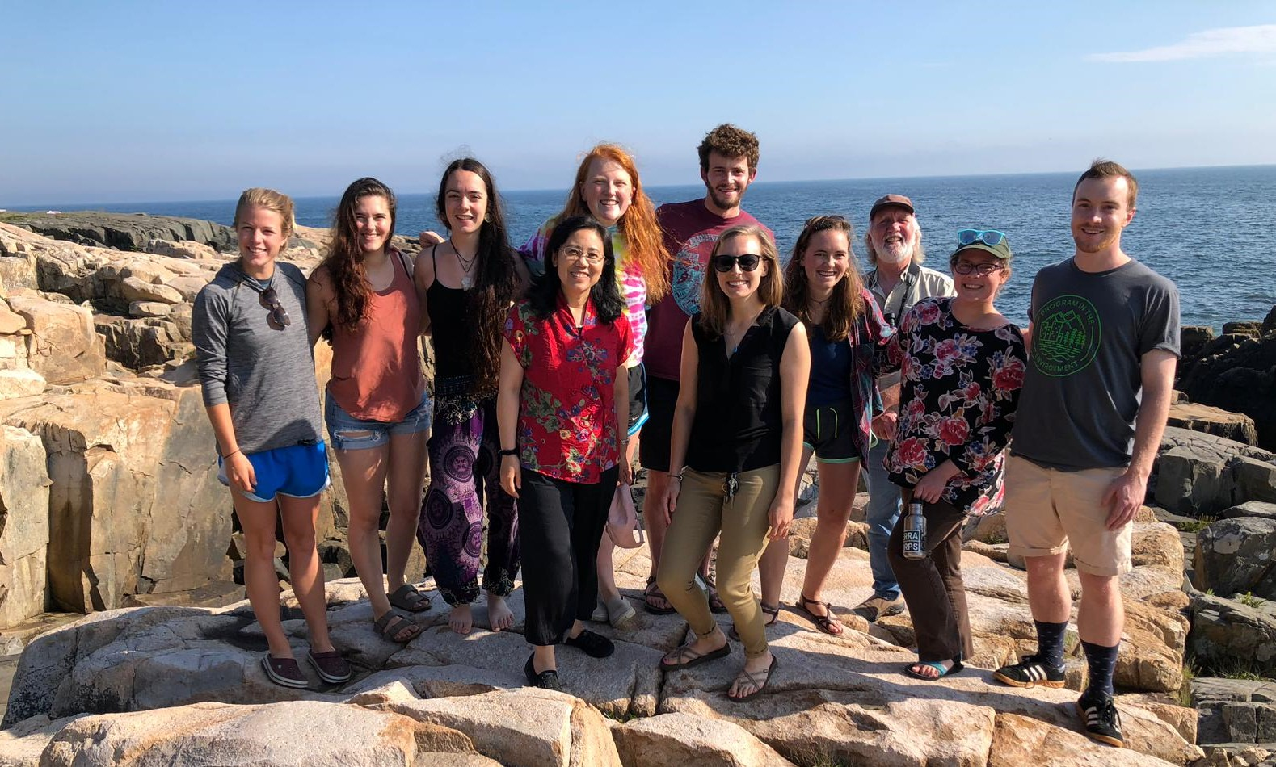

During the two intensive weekends, students heard presentations from a variety of leaders in land conservation including David Foster, Director of the Harvard Forest and faculty member at Harvard University, Lee Youngblood, Executive Director of the Mount Grace Land Trust in Central Massachusetts, Paul Catanzaro, faculty member of University of Massachusetts, Buzz Constable, President of the Massachusetts Land Trust Coalition, Keith Ross, Senior Advisor at LandVest, Richard Paradis, faculty emeritis at University of Vermont and Aaron Dority, Executive Director of Frenchman Bay Conservancy in Maine. Students also had writing assignments, field trips, hikes in the woods and mountains, and opportunities to reflect on their summer work and career aspirations and participate in leadership and prospective thinking exercises. They were highly articulate, thoughtful, curious, and ready to learn and immediately showed the ability to collaborate, as well as strong listening and speaking skills.
With now 3 cohorts of participants, ALPINE is developing a network of alumni of the program that will communicate with each other to share opportunities and stories and have opportunities to get together again in the future.
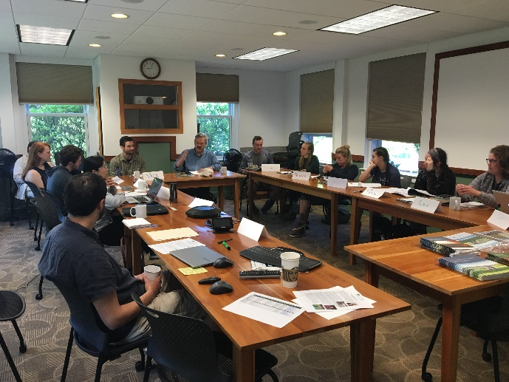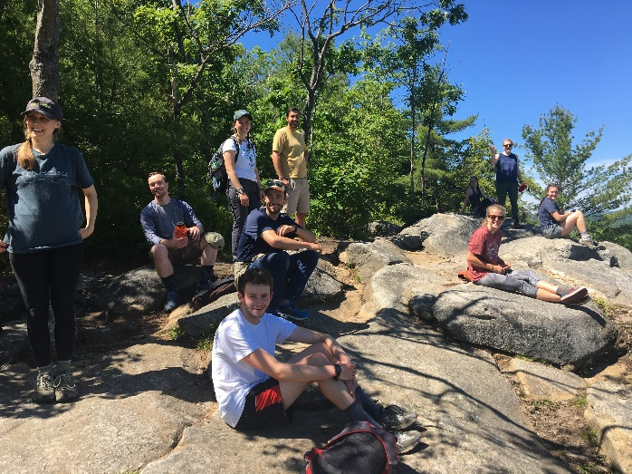
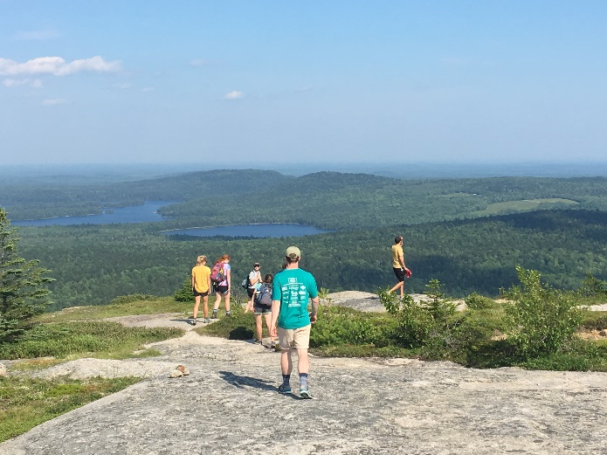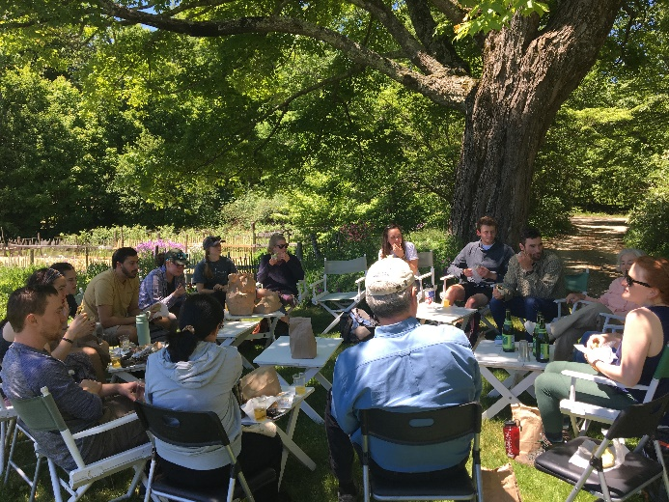
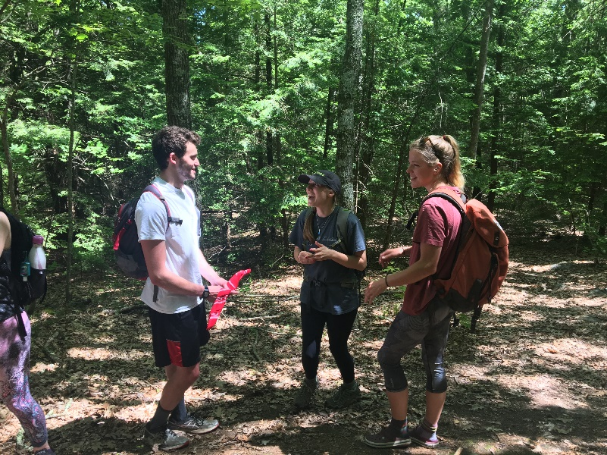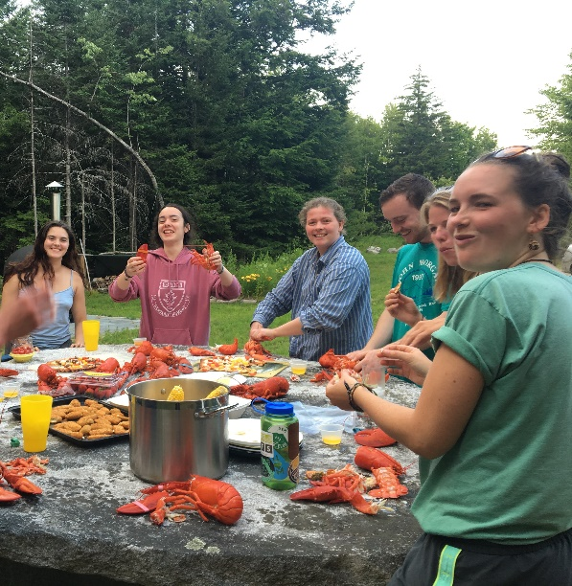
ALPINE Summer Institute Final Reflections

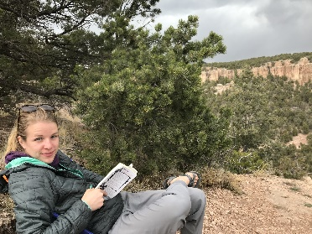
Danielle Wards is a rising senior at Bates College in Lewiston, Maine, where she is majoring in English and environmental studies. After graduating, she hopes to pursue a career in science communication. Specifically, she is interested in land conservation because it is an ideal platform for educating non-academic audiences on environmental issues. Outside of my academic interests, she enjoys rock climbing, going to the beach, and backpacking.
Reflection
This summer, I have been afforded a number of opportunities that have fortified my interest in pursuing a career in land conservation. One of these opportunities was my job at Deep Cut Gardens, which allowed me to witness the impact of conserving land for public use. My day-to-day tasks in the workplace included tending to the extensive gardens and trails, answering visitors’ questions, and carrying out administrative tasks. My position blended physical labor in the gardens and administrative work in the Horticultural Center. One of the most meaningful aspects of my work was my ability to witness visitors’ enjoyment and engagement with the space.
I found that my participation in ALPINE provided a larger context for my role at Deep Cut Gardens. At ALPINE, I heard from professionals with a wide range of interests regarding land conservation. Similarly, I witnessed a range of familiarity and interest in land conservation from visitors at Deep Cut gardens. Seeing individuals’ different approaches to land conservation has helped me appreciate the complexities, nuances, and impact of this field. I now consider land conservation a highly interdisciplinary topic, which benefits from numerous perspectives.
Through working at Deep Cut Gardens, which is one of the parks in the Monmouth County Park system, I became more familiar with the extensive network of open, public greenspaces in my local community. One of the lessons I learned at ALPINE was the history of greenspaces in the United States, which has been attributed to the Puritan settler, John Wingthrop, and his initiatives in the 1600s. I also heard a number of speakers at ALPINE attest to the systems approach to establishing greenspaces. This helped me appreciate the power and influence that parcels of conserved land have when they are part of larger networks. My job environment this summer represented these two lessons from ALPINE, which helped me gain a deeper understanding of some of the common characteristics of conserved land in New England.
In addition to the context that ALPINE provided my work, I walked away from the program with new friends and connections with people with shared values as myself. I look forward to the future, where I expect our paths will cross again.

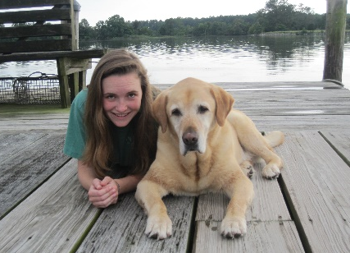
Colby Bosley-Smith grew up in Washington, DC and was interested in nature while exploring various ecosystems in Rock Creek Park and the Chesapeake Bay. She is currently a rising senior at the University of Vermont, pursuing a degree in Environmental Sciences with a concentration in Conservation Biology and Biodiversity and a minor in Forestry. This summer she is excited to be working as a research technician for the Adaptive Silviculture for Climate Change (ASCC) project which is testing various silvicultural approaches to climate change adaptation at five study sites across the country. She is working on several research initiatives for the ASCC project at the Dartmouth Second College Grant in New Hampshire. Moving forward, she hopes to continue to engage in forestry research while spending as much time outside as possible.
Refection
I have always had a desire to work, play and spend as much time outside as possible. Too much time spent indoors, and I begin to go crazy. I am most content hiking through a forested mountain range, biking along a coastline or swimming across a lake. This longing to be outside in natural areas, compelled me to study Environmental Sciences and gradually develop an interest in forest ecology research. For the first time this summer I gained a sense of what a career studying forest ecology might entail.
A large portion of my summer has been spent devising creative solutions to ward off mosquitoes and learning how to deal with consistently soggy and smelly boots. Work as a forestry field research technician is not easy. This past week my crew hauled all of our field equipment along with personal backpacking gear up a mountain where we spent the next four days bushwhacking through steep, rocky, old-growth forest to set up plots and core trees in the White Mountains. By the end of the week I was in dire need of a shower, clean clothes and a fresh cooked meal, yet I was remarkably content, eager for the next week of field work adventures.
My summer as a field technician has aligned closely with my expectations. Some days in the field are incredibly long and exhausting yet my summer experience has allowed me to explore beautiful forests and engage in fulfilling work experiences. I spent the first few weeks of the summer inventorying forest plots for the Applied Silviculture for Climate Change project at the Second College Grant in northern New Hampshire. These particular plots are part of a nationwide study to understand the most effective ways to manage forested lands as our landscapes are altered by the threat of climate change. Additionally, I have had the opportunity to monitor the health of seedlings planted for an assisted migration study, install sensors on logs for a dead wood study and core trees in mixed-wood old growth ecosystems to study the growth patterns of red spruce. I have had the opportunity to work alongside some of the most influential forest ecologists in New England and observe the intricacy of research initiatives.
Attending the ALPINE program helped me conceptualize the importance of my summer work. Prior to attending the first ALPINE seminar, I was largely unfamiliar with land conservation. I had always taken for granted the beautiful conserved natural areas that I often explore yet had never taken the time to contemplate how they came to be conserved. It was exciting to connect with leaders in the field as well as the other students whose conservation legacies were just beginning. At first I considered myself an outsider in this group of students mainly engaged in the political, social and mapping aspects of conservation through land trusts. By the end of the program, however, I understood that conserving land is a multi-faceted field. If we wish to continue to study red spruce regeneration in old-growth forests than well managed, conserved land is necessary. I hope to someday be able to devise my own research projects that advance the way we think about and take care of the complex forested ecosystems on these conserved lands. Ultimately, I hope that this allows me, and others more time to explore natural areas.

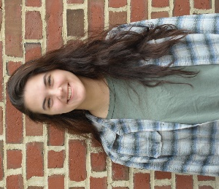
Anna Therein is a student at Westfield State University. She is majoring in Regional Planning and Environmental Science with a minor in GIS. This summer she is interning at Harvard Forest in Petersham, Massachusetts.

Reflection
During the summer of 2019 I had the opportunity to intern at Harvard Forest in Petersham, Massachusetts. While there I was working on a project called Advancing Wildlands and Woodlands through Conservative Collaboration. Wildlands and Woodlands is a vision for conservation in New England. It calls for protection of 70% of the forests and 7% of the farmlands. This vision is great, but we need to find ways to implement it.
My personal project in relation to Wildlands and Woodlands was to look at a smaller region within New England. My focus area was the Pioneer Valley within Massachusetts, which is made up of three counties, Franklin, Hampshire, and Hampden. It was important to look at a smaller area because you can learn more about the individual towns, counties, and region. We learned what was important to a town by reading their Open Space and Recreation Plans (OSRPs). OSRPs are created from input and feedback from the townspeople. If a town wants to receive state funding for projects related to open space and recreation, they need to have one of these plans. These documents provide a comprehensive description of the community, the natural resources they have, community surveys/opinions, goals, objectives, and a seven-year plan to complete the objectives they outline. We collected 62 OSRPs and obtained data from them, mainly focusing on their goals/objectives and their seven-year action plans. These data were combined into an excel sheet with different categories. I then took the text we had collected from the OSRPs and quantified it. By doing this I was able to quantify and analyze town goals. The resulting Excel sheet and maps made from the data are tools that can help inform land trust, planning, and community partners in a developing regional conservation partnership to advance their conservation work in a way that makes sense for different regions and towns.
I learned a lot about conservation through this internship, but I was lucky enough to expand my knowledge on the subject even further by attending the ALPINE summer institute. I was encouraged to apply to the program by my summer mentors, and I am glad I did. I learned a lot and was challenged to think about myself in ways that I usually try to avoid. The first weekend I was nervous and didn’t quite know what to expect.
We started off the program by thinking of how the land has changed over the centuries. This encouraged conversations between us participants about why it was important to protect the land now before it gets developed or clear-cut again. During the first session we also had to come up with a Before Action Review for ourselves, a plan of what our summer was going to be like and what we were thinking of for our future over the next few years. This assignment was thought-provoking for me, it made me think about how much my interests have changed just over the past year and how they can continue to do so. We presented our plans to the other participants and they gave me feedback, advice, and resources that might help me in my future endeavors. Connecting with peers that were interested in the same field as me outside of my typical school environment was one of the best parts of the first weekend.
The second weekend in Maine involved us listening to more people who worked on large scale conservation projects and learned how they connected with landowners, fundraised, and increased awareness. Hearing from the people that oversaw these projects was very beneficial for me because they all had different backstories. None of them went into conservation right away and they tried out a few things first before they found what they loved. The second weekend helped me think about how there are so many ways to be involved in conservation. It is a diverse field, whether it’s the type of land/habitat you are protecting, or how the land is protected. We ended the weekend by completing an After-Action Review, reflecting on how our summer went, and again looking forward to the next few years. Overall, I was very happy with both my internship and the ALPINE summer institute. I felt like they contributed to my education and taught me a lot about the fields I intend to enter. They also made me very confused because now I am considering careers I never would have thought of. This scares me a little, but mostly it makes me excited to think about it more and see what really resonates with me.

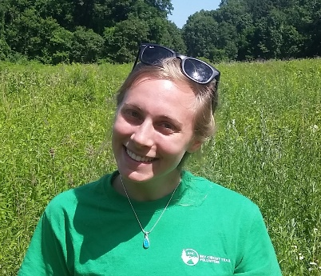
Kayla Dorey graduated from the University of Vermont in 2014 with a Bachelor of Arts in Environmental Studies with a focus in Ecology and Conservation. Currently, she is a teaching assistant in the Special Education department at Ipswich High School as well as a graduate student at Salem State University studying Geo-Information Science. She will be interning this summer with Essex County Greenbelt Association to learn more about the application of GIS for local conservation.

Reflection
Five years after graduating from my Environmental Studies program at University of Vermont, I still feel uncertain about my future. My expectations for life after college were to work a couple years, networking and eventually finding jobs that led to a full-time year-round position in conservation. Since college, I’ve held several seasonal field positions doing trail stewardship, stream crossing surveys, and environmental education for conservation organizations. However, for the past two years, I have been working at a high school in Special Education while earning my master’s in Geographic Information Systems (GIS). While peers have urged me to “just become a teacher,” I have grasped onto the idea of being a land conservationist. Though I understood my love for the outdoors and was confident of the knowledge learned from my past experiences, I was unsure of the concrete next steps to realizing the career in conservation that I had imagined for myself.
My weekend at Harvard Forest began to shift my perspective on my career thus far after college. Each speaker, most notably Leigh Youngblood of Mt. Grace Land Conservation Trust, spoke about his or her meandering path to get to the success, and more importantly happiness and fulfillment, that they are experiencing now in the field of conservation. My path has been far from linear. I learned that being uncertain of my next steps is normal and to think about my interdisciplinary skillset as an asset. My enthusiasm for nature and interest in acquiring practical skills have been the driving forces behind my career decisions. I walked into my summer internship after the first weekend at ALPINE with new lenses; I had an opportunity to listen and learn from others new skills to put in my tool belt.
I have spent my summer as a GIS intern for Essex County Greenbelt Association, a land trust that has protected many properties surrounding my home in Topsfield, Massachusetts. Primarily, I have been working on a story map, an immersive webpage, for one of Greenbelt’s newly acquired properties called the Castle Neck River Reservation. My task was to develop written content and media that highlights the partnership that made the acquisition possible as well as the property for its historical, ecological, and recreational significance to the local community. As I continue my internship into the fall, I aim to be more mindful of how I use my time at Greenbelt, specifically listening to other staff who specialize in different aspects of the land trust. The highlight of my summer so far was the opportunity to band osprey chicks, guided by the Director of Stewardship. I have spent time updating Greenbelt’s parcel database, reading deeds and other real estate documents that are integral to land protection. I hope to learn more about the process of fee property acquisition and the negotiation of conservation restrictions (CRs), perhaps by attending site visits, negotiations, or town hall meetings.
From my experience at ALPINE, I learned to find comfort in the uncertainty of what’s next for my career. Land conservationists, from Massachusetts to the Schoodic Peninsula in Maine, spoke to the participants at ALPINE and each echoed the importance of building trusting relationships, talking and listening to others, be it landowners or colleagues. This advice is not only practical for anyone employed for land trusts when working with landowners, but it is also applicable as I complete the rest of my internship with Greenbelt. I intend to gain valuable knowledge from my experience at Greenbelt and beyond by developing positive relationships with my peers, asking directly for more opportunities, and listening to all the information my mind can soak up. While I do not know what opportunity will come next, I aim to take full advantage of the current opportunities I have been given on North Shore of Massachusetts as a GIS intern, graduate student, and educator.

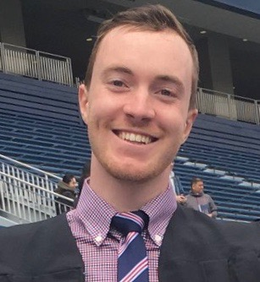
Joe Hazleton is graduating from the University of Michigan in August. He is originally from Arlington, MA, and is now living in northern Michigan studying plants, and later in the summer interning at the Kennebec Land Trust studying GIS and Abenaki culture in Maine. In the next few years he’ll try to find his way to grad school on the law and policy side of environmentalism. For green free time reading, he digs Gary Snyder––The Real Work is worth flipping through if you ever catch it at a thrift store or library. He likes to swim and bike and run marathons, but triathlons sound a little extra, maybe one day.
Reflection
ALPINE introduced me a set of finish lines for work in line with my ideals for conservation and joined me with peers who can help me in that direction. Through college at a big state school––I lost my way over and over by competing with peers whose end goals were so far from mine, that even my highest level of work would throw me off course.
At the end of June, I had complete freedom to design a research project for my summer internship with the Kennebec Land Trust in Mid-Coast Maine. I took more or less the easiest way forward, consulting with our Executive Director, Theresa Kerchner to choose a subject that she had already prioritized. I liked her guidelines about using a newly acquired fee property––an early-successional forest on a hill––to demonstrate to the public the benefits of sustainable forestry. But somewhere in the process of laying out an informational brochure, I lost the thread of my initial interest.
At this point, I’m writing about forest regeneration to fight climate change in Maine in a way that I don’t fully believe. The influence of the KLT is at a fairly small scale. Where, as we learned from Keith Ross on ALPINE weekend two, conservationists in Northern Maine can set aside 100,000+ acres at a time, in Central Maine land trusts can only typically only work ~100 acres at a time. The implications of my project are at best, that I will persuade several people with these smaller size parcels to donate their forests for conservation and long rotation harvest.
Right now I need to reengage with my research. As I’ve seen at ALPINE even the smallest land trusts have teeth as part of state and regional level conservation initiatives. I’ll reengage by learning about mass-communication, and new ways to visually represent forest data on KLT properties. If I can be happy with the final product, the impact of my research will fall outside of my goals for the internship. Prima facie this might look pessimistic, but if my research serves a long term goal of improving my skill with larger environmental action / activism, my final product for this internship will be trifling. For the time being my goal is to write a brochure, and create a web page that looks best in my professional portfolio (which can never hurt the project's broader impact).
ALPINE helped me immeasurably in that way––by allowing me to understand the wider context of environmental jobs for young people. In college, I might have knocked myself for missing some quixotic ideal, but I’ve seen from peers in our ALPINE cohort that we can’t expect to lead projects at a broad scale in our early 20s. Incremental progress through graduate school, work experience, etc., will land us where we can make these ideal steps of regionally and nationally significant projects, as we saw from ALPINE speakers like Keith Ross and Leigh Youngblood, but at this young-ish age, we have to take the monotony in stride. Of course, some ALPINE students like Jacob Freedman set a great example of the impact achievable before your 20-somethings. But as even Jacob is reaching larger milestones for Wild Middlebury after a year-plus of work, he’s shown the same need for incremental progress.
I’m happy with where I am, and I’m happy to stay the same course. At the end of the second ALPINE session Jim called me the “Zen master” of the group, which could only mean that I look like the biggest stoner, but as Aldo Leopold says––and I’m stealing this from past ALPINE participant Matt Brewer–– “Conservation is a state of harmony between men and land.” I’m more sure of my career direction after begin asked to reflect both weekends at the Harvard Forest and Schoodic Institute. With this “Zen” I’ll take my next steps toward conservation mastery in the fall.
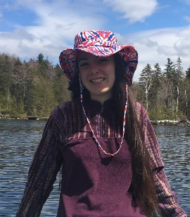
Mattea Powers grew up in Skowhegan, Maine and is a rising senior at Plymouth State University studying Environmental Science & Policy and earning a GIS certificate. As a reflection of these skills, she is currently interning at Harvard Forest in Petersham, Massachusetts. In the future, she is interested in pursuing a career in conservation ecology with an emphasis on GIS.

Reflection
Academics for Land Protection in New England (ALPINE) brought me insights and gave me the opportunity to listen to and learn from knowledgeable individuals in land protection.
My summer REU internship at Harvard Forest ran parallel with ALPINE. For 11 weeks, I researched how to bring the Wildlands and Woodlands (W&W) goal of protecting New England landscapes as 70% forests and 7% as farmlands down to a smaller scale, to the Pioneer Valley (Hampden, Hampshire and Franklin counties) of Massachusetts. Through ALPINE, I learned that connecting with landowners lets them feel comfortable enough to let someone (i.e. a land trust) protect their land while also still allowing them to have freedom to do things like sustainable forest harvesting and so on. I applied what I learned from ALPINE ideas to the results I want to bring to land trusts to help them communicate with landowners to conserve land.
The results? I created maps of the Pioneer Valley that can show land trusts and landowners where new development has occurred since 2001, and where that new development intersects with prime agricultural soils and BioMap2. Without having heard the speakers at ALPINE, I wouldn’t have thought to make maps that speak to each landowner individually. Maps are powerful and may motivate landowners to protect their land when seeing how rapidly development is compromising prime soils, forests, and habitat for biodiversity.
The people I met during the two weekends of ALPINE were incredible. Although most of us are just starting out in this field, each and every one of the participants taught me something. I value the advice that everyone gave me and how each and every single person listened to my and every else’s goals that we have for our careers and life paths. Talking to everyone brought me many different perspectives on what you can do in this field, and the confidence that anything that you do will be important. The speakers that Jim and Marianne organized were extremely helpful and provided insightful talks. Learning how each of them got into land protection, and what land protection means to them, allowed me to feel that I am in the right field with people as dedicated to land protection as I am.
During the first weekend, we did before action reviews (BARs) in front of the whole group. We said how we hoped our summer internships would be and what our goals were. We also talked about where we see ourselves in the next few years. The group provided feedback on internships, jobs and other helpful resources to help us reach our future goals.
The second weekend of ALPINE was extremely fun and useful. Coming back almost a month after first meeting everyone and learning their summer jobs and internships, you learn that sometimes summer jobs or internships are not what you thought they would be, and that sometimes they are everything you hoped and wanted. Either way, you learn something about yourself professionally and personally. For me, ALPINE allowed me to do just that. By talking and getting to know the other ALPINE participants, I made connections and friendships I hope to keep throughout my career.

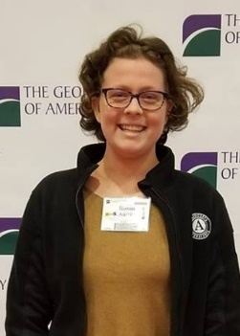
Robin Austin is originally from Durango, CO, but moved to Massachusetts to attend Smith College. She graduated with a degree in Geosciences in 2018. She is currently serving a TerraCorps/AmeriCorps term with North County Land Trust in Leominster, MA. Previously, she served as an AmeriCorps member with the San Juan Forest Service in their Abandoned Mine Lands division. Her interests are land stewardship, sustainability, and climate change resiliency. In her free time, you can find her hiking, reading, listening to podcasts, or starting a new craft project.

Reflection
I chose to apply for the ALPINE Summer Institute at the advice and recommendation of a previous participant. I was initially unsure about applying since my AmeriCorps term had started in September, and was not just a summer, but I thought it was worth a try anyway. I am so grateful to have been accepted! Nearing the end of my 11 month term in a regional land conservation organization, I was unsure what direction I would go or where my skills could be best applied in the area of land conservation. I had had a lot of experience in projects ranging from trail construction, to community outreach, to stewardship, to land acquisition, and I wanted to take what I had learned and translate it to a path moving forward.
During the first ALPINE weekend at the Harvard Forest in Petersham, MA, I was inspired by the wide range of projects that the ALPINE Participants were doing. Hearing about the variety of projects inspired me to think more deeply about the type of work that can make a difference in land conservation, and where I thought I fit into that framework. Speakers were brought in that also illustrated this range in experiences and career paths- From Leigh Youngblood, Executive Director of Mount Grace Land ConservationTrust, to Paul Catanzaro, Extension Associate Professor at UMass. Our weekend theme was the Tully Lake project: an expansive land conservation effort in the north central Massachusetts region. Our speakers and activities highlighted the importance of collaborative efforts from different organizations and the critical impact that a few key players could have on the direction and success of large landscape conservation.
This was echoed in the second ALPINE Summer Institute weekend, which occurred at the Schoodic Institute in Maine. This speaker series highlighted the importance of involving landowners and more non-traditional partners, like colleges, universities, and business. This weekend was enormously enlightening for me as it demonstrated the importance of relationships in land conservation. It also demonstrated that there are many ways to conserve land, and that those projects are shaped not only by the importance of habitat and landscape, but also by funding sources, community involvement, level of threat, and many other factors.
Ultimately, the most useful portion of this experience was being able to speak with like-minded individuals with a wide range of experience in the land conservation world. My fellow ALPINE Participants had great feedback for me regarding both my service year projects and my career plans. The speakers and educators were engaging, helpful, and extremely knowledgeable. I am walking away from the ALPINE Summer Institute with a much more significant depth of knowledge about the world of land conservation, as well as a lot of insight into how I can make a difference.
Because of my experience in my TerraCorps service year and at the ALPINE Summer Institute, I have decided to go back to get a Certificate in Geo-Information Science. I look forward to working to conserve land in the New England Region! Thank you to the Lincoln Institute, the wonderful speakers and educators, the other participants, and the supporters of the ALPINE Summer Institute for making this a memorable and valuable experience!
OTHER PARTICIPANTS
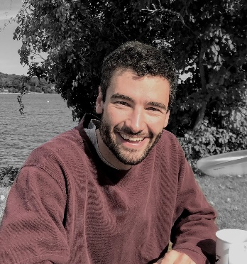
Jonathan Brown grew up in Hanover, NH. He took a gap year before college and returned to Hanover to go to Dartmouth where he studied mechanical engineering. His first job after college was as a manufacturing engineer for a biotech startup in San Francisco. Seeking a pivot, he moved to Costa Rica summer of 2017 and spent eight months volunteering for a variety of environmental projects. Summer of 2018, he worked as a backpacking trip leader in Alaska for Overland Summers. Then he moved to Cambridge, MA and began an internship at The Charles River Watershed Association to help them with their initiative to design, plan, and install more green
Sabrina Guihong Wei is a professor of law at Beijing Forestry University in Beijing, China. She is also the director of the Law and Policy Institute for State-Owned Forest Farms and the editor in chief of the State-Owned Forest Farms Journal, which publishes research on the practice of sustainable management and forest operations for 4,855 state-owned forest farms in China. While at the Lincoln Institute, Sabrina is studying the history and application of the conservation easement as a legal tool to advance land protection in the United States. She is also studying how the practice might be relevant in China. She will continue her work remotely with the network of civic land conservation practitioners in China.

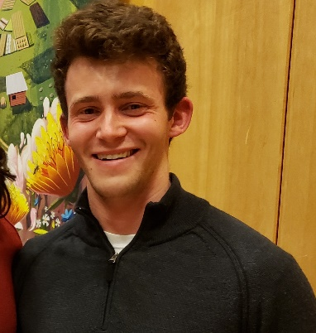
Jacob Freedman is a rising Junior at Middlebury College in Vermont majoring in Environmental Studies and Geography. He is originally from Worcester, Massachusetts, and this community has inspired him to care about local conservation. He is a co-founder of the Wild Middlebury Project, an organization that seeks to connect and engage young people with local and place-based environmental initiatives. This summer, he will be working with ALPINE to create a toolkit for other colleges and universities to start similar organizations in their own communities. He is excited to attend the ALPINE summer institute and learn from my peers in conservation across New England. In his spare time, he enjoys teaching skiing, exploring Addison county with my 7-year-old mentee, discussing local Worcester politics, and sharing in the passions and interests of others.

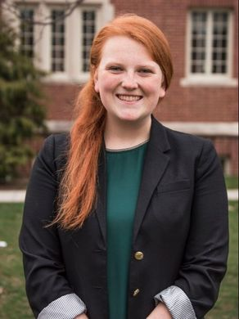
Katherine Lange is a graduate student at the University of Connecticut pursuing my Master's in Public Administration with a concentration in environmental policy. She currently works for the Connecticut Land Conservation Council as the Sandy Breslin Conservation Fellow, where she assists with advocacy efforts on state policies, particularly within the Land Trust community. In the fall, she will begin working for the Connecticut Fund for the Environment/Save the Sound based in New Haven. She is from Lebanon, CT, earned a B.A. in Political Science and Human Rights from the University of Connecticut in 2018 and enjoys hiking and camping.

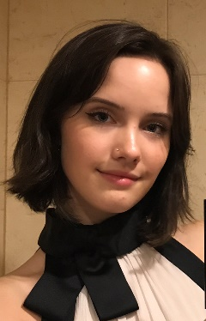
Madison Shaw started a grassroots organization in 2013 and became enveloped in the world of public health. For the last seven years, she has dedicated her life to advocacy on behalf of the rare disease community. Now, as a sophomore in college, she is studying Political Communications and Environmental Studies at Emerson College in the hopes of carrying this work into her career. She is always working to understand the symbiotic relationship between conservation and public health and finding an intersection at which great change can be made. Madison will be working with Spencer Meyer at the Highstead Foundation and Marianne Jorgensen on a health and the environment project this summer.

